Batter Preparation (BAT)

Scope Note

Stakeholders
- Production & Logistics Management (production orders, recipes, ingredient stock)
- Warehouse Management System
- Human Inspector (mandatory batch inspection, UC4)
- Maintenance Department
- Machine Health Monitor
- Thermal Processing (receives the finished batter)

Needs, Goals, and Objectives
- Need: Raw ingredients staged at the batching station must be turned into correctly weighed, fully mixed, inspected batter, ready to be deposited onto a pan.
- Goal: Only batter made from correct ingredient quantities and passed by a human inspector reaches the production line, and a fault in dosing or mixing costs at most the batch it affects.
- Objectives: Dispense and verify every ingredient against the recipe target; recover from an under-dose and discard an over-dose; lock out a repeatedly failing doser; mix for the recipe-defined time under consistency monitoring; gate every batch behind human inspection; hand the batter over before it waits too long.

System boundary
- Inside the boundary: Ingredient dispensing and weighing, dose verification and correction, the dosing fault lockout, the mixing cycle and its consistency monitoring, the human batch release gate, the batter holding buffer and its waiting-time limit, and the reporting of events and health for these functions.
- Outside the boundary: Ingredient stock and reservation (Production & Logistics Management), depositing the batter onto a pan and everything downstream of it (Thermal Processing), fault ticketing and repair (Maintenance, through Line Monitoring & Health), and the warehouse itself.
- Primary functionality: Turn staged raw ingredients into one batch of correctly weighed, fully mixed, human-inspected batter, and hand it over before it has waited too long.
- Target users: The human inspector, who records a verdict for every batch; maintenance technicians, who act on dosing and mixer faults; and the production scheduler, whose orders drive the slice.
- External interactions: Three counterparts: Production & Logistics Management (orders, recipes, ingredients), Thermal Processing (batter handoff and the depositing state), and Line Monitoring & Health (events, heartbeat and repair confirmations). These are the seven signals in the External Interfaces table; nothing else crosses the boundary.

Drivers and Constraints
- Every mixed batter batch must be human-inspected before being allowed for further production (UC4 business rule).
- Only correctly weighed ingredients may be loaded into the mixer (UC3 postcondition).
- Only organic ingredients may be used in cake production (UC1 business rule).
- An over-dosed batch cannot be corrected and must be discarded (FC4).
- A rejected batch is re-mixed immediately rather than discarded (UC4 alternative flow).
- Services run in Docker containers.
- Components report through the message bus.
- This slice is not 24/7-critical and both subsystems are independently deployable (Table I of the report), so a short stop here is acceptable where a stop in the thermal path would not be.
- Availability is the group's main quality attribute. Of the five failure cases in this slice, three (FC3, FC4, FC7) are handled by the system and two (FC5, FC6) need Maintenance.

Scenarios
- Nominal: A production order with its recipe targets arrives from Production & Logistics Management. Ingredients are requested and reserved, then dispensed into the mixer one at a time, each weighed by the load cell and compared against its recipe target. When every ingredient is within tolerance the batch is signalled complete, the mixer runs for the recipe-defined duration under consistency monitoring, the finished batch is presented to a human inspector, and once marked good the signal "Batter ready" is sent to Thermal Processing.
- Off-Nominal:
  - an ingredient is under-dosed and is topped up, then re-weighed (FC3)
  - an ingredient is over-dosed, so the batch is discarded, logged and restarted (FC4)
  - dosing fails several times in a row, so dosing is stopped and Maintenance is called (FC5)
  - the mixer breaks, so the batch in the mixer is discarded and Maintenance is called (FC6)
  - the inspector marks a batch not good, so a further mixing cycle starts immediately (UC4)
  - depositing stops, so finished batter waits, is discarded once it has waited too long, and new batches are held until depositing reports working again (FC7)
  - the warehouse reports insufficient stock, so dosing does not start (FC1, FC2)

External Interfaces
Signal name | Direction | Counterpart | BAT block | Carries | Source
Production order and recipe targets | In | PLM | Order & Ingredient Intake | Production order, batch ID, per-ingredient recipe targets and tolerances | UC1, UC3
Ingredient request and reservation result | In / Out | PLM | Order & Ingredient Intake | Requested ingredients and quantities; reservation result (confirmed / insufficient stock) | UC1, FC1, FC2
Batter ready | Out | THM | Batter Handoff Control | Finished, inspected batter with its batch ID, handed off to depositing | UC4
Depositing stopped / working again | In | THM | Batter Handoff Control | Depositing has stopped, or is working again | FC7
Log, warning, error and discard events | Out | MON | Event Reporting | Reason, time, batch ID for every logged, warned, failed or discarded batch | UC2, FC4, FC5, FC6, FC7
Machine status (heartbeat) | Out | MON | Health Reporting | Heartbeat and health state of every function and device in the slice | UC2, FC5, FC6
Repair confirmed | In | MON | Dosing Fault Lockout; Mixer Fault Handling | Machine ID, repaired | FC5, FC6
THM = Thermal Processing; MON = Line Monitoring & Health and Band Transport; PLM = Production & Logistics Management.

Requirements

Parameters
Thresholds the requirements depend on. Each requirement refers to its parameter by ID, so only the value is outstanding.
ID | Parameter | What it governs
P1 | Dose tolerance | How far a measured dose may sit from the recipe target before it counts as under- or over-dosed. Depends on the recipe and on the accuracy of the dispenser.
P2 | Maximum consecutive failed dose measurements | The point at which repeated correction stops looking like a bad dispense and starts looking like a faulty doser.
P3 | Maximum batter waiting time | How long mixed batter stays usable, and therefore how long a depositing stop can last before the batch is lost.
P4 | Health status interval | How often health is reported. Must be shorter than the Health Monitor's own detection window, otherwise a missed report is ambiguous.
P5 | Fault report latency | How quickly a stopped function or device must become observable. Makes BAT-NFR-04 testable once a value exists.

Functional Requirements
Req ID | Requirement | Rationale | Source (UC/FC) | Feature ID | Block ID(s)
BAT-REQ-01 | The system shall receive the production order and its recipe targets from Production & Logistics Management before dosing begins. | Entry point of the slice; dosing cannot start without recipe targets. | UC3 | BAT-FEAT-02 | BAT-AF-01
BAT-REQ-02 | The system shall associate every batch with the batch ID of its production order, from intake until the batter is handed off to Thermal Processing. | Batch traceability for recall; the batch ID is reported with every discard event. | UC3, UC4 | BAT-FEAT-21 | BAT-AF-12
BAT-REQ-03 | The system shall request the ingredients required by the production order from Production & Logistics Management, and shall not begin dosing until the request has been confirmed. | Ingredients must be reserved before dosing starts; insufficient stock stops the batch before any ingredient is dispensed. | UC3, FC1, FC2 | BAT-FEAT-02 | BAT-AF-01
BAT-REQ-04.1 | The system shall dispense each ingredient of the recipe into the mixer. | Normal dosing flow. | UC3 | BAT-FEAT-03 | BAT-AF-02, BAT-FD-01
BAT-REQ-04.2 | The system shall measure the dispensed weight of each ingredient. | A dispensed quantity that is never measured cannot be checked against the recipe. | UC3 | BAT-FEAT-04 | BAT-AF-03, BAT-FD-02
BAT-REQ-04.3 | The system shall compare each measured weight against its recipe target. | Comparison against the target is what turns a measurement into a pass or a fail. | UC3 | BAT-FEAT-04 | BAT-AF-03
BAT-REQ-05 | The system shall treat a batch as ready for mixing only when every ingredient of the recipe is within the dose tolerance (P1) of its recipe target. | Only correctly weighed ingredients may be loaded into the mixer (UC3 postcondition). | UC3 | BAT-FEAT-04 | BAT-AF-02
BAT-REQ-06.1 | The system shall request the missing amount of an ingredient when its measured weight is below the recipe target. | An under-dose is recoverable, so the batch is topped up rather than wasted. | FC3 | BAT-FEAT-05 | BAT-AF-02, BAT-FD-01
BAT-REQ-06.2 | The system shall weigh an ingredient again after every top-up. | A top-up is only a correction if the result is verified; otherwise the batch may still be wrong. | FC3 | BAT-FEAT-05 | BAT-AF-03, BAT-FD-02
BAT-REQ-07.1 | The system shall discard the batch when the measured weight of an ingredient exceeds its recipe target. | An over-dose cannot be corrected by removing ingredient, so the batch is lost. | FC4 | BAT-FEAT-06 | BAT-AF-02, BAT-FD-05
BAT-REQ-07.2 | The system shall record a discard, with its reason and the batch ID, for every batch discarded because of an over-dose. | A discarded batch must stay traceable for recall and for the waste figures. | FC4 | BAT-FEAT-06 | BAT-AF-10
BAT-REQ-07.3 | The system shall start a new batch after discarding an over-dosed batch. | Production continues after a discard; the order is still outstanding. | FC4 | BAT-FEAT-06 | BAT-AF-02
BAT-REQ-08.1 | The system shall count consecutive failed dose measurements. | Repeated failures point at a faulty doser rather than at a bad batch. | FC5 | BAT-FEAT-07 | BAT-AF-04
BAT-REQ-08.2 | The system shall stop dosing when the number of consecutive failed dose measurements reaches the maximum (P2). | Stopping bounds the waste: without a limit a faulty doser keeps spoiling batches. | FC5 | BAT-FEAT-07 | BAT-AF-04, BAT-AF-02
BAT-REQ-08.3 | The system shall record an error, with the batch ID, when dosing is stopped because the maximum consecutive failed dose measurements (P2) was reached. | Maintenance is notified through Line Monitoring & Health. | FC5 | BAT-FEAT-07 | BAT-AF-04, BAT-AF-10
BAT-REQ-08.4 | The system shall resume dosing only after it has received the signal "Repair confirmed" for the doser. | Prevents restarting on a doser that is still faulty. | FC5 | BAT-FEAT-07 | BAT-AF-04
BAT-REQ-09.1 | The system shall start the mixing cycle when batch loading is complete. | Normal mixing flow. | UC4 | BAT-FEAT-09 | BAT-AF-05, BAT-FD-03
BAT-REQ-09.2 | The system shall run every mixing cycle for the recipe-defined duration. | Under-mixing and over-mixing both spoil the batter, so the duration is recipe-defined rather than fixed. | UC4 | BAT-FEAT-09 | BAT-AF-05
BAT-REQ-10 | The system shall monitor batter consistency throughout the mixing cycle. | Consistency is monitored during mixing (UC4 normal flow). | UC4 | BAT-FEAT-10 | BAT-AF-06, BAT-FD-04
BAT-REQ-11.1 | The system shall present every finished batch to a human inspector before release. | Business rule: every mixed batter batch must be human-inspected before being allowed for further production. | UC4 | BAT-FEAT-12 | BAT-AF-07, BAT-FD-06
BAT-REQ-11.2 | The system shall not release a batch for handoff until that batch has been marked good. | The business rule makes the inspection a gate, not an advisory step. | UC4 | BAT-FEAT-11 | BAT-AF-07
BAT-REQ-11.3 | The system shall schedule a further mixing cycle immediately for every batch that is not marked good. | A rejected batch is re-mixed rather than discarded (UC4 alternative flow). | UC4 | BAT-FEAT-14 | BAT-AF-07, BAT-AF-05
BAT-REQ-12 | The system shall make a batch available to Thermal Processing for depositing, together with its batch ID, once that batch has been marked good. | Handoff point of the slice. | UC4 | BAT-FEAT-17 | BAT-AF-09
BAT-REQ-13.1 | The system shall stop the mixer when a mixer fault is detected. | Mixer fault handling. | FC6 | BAT-FEAT-15 | BAT-AF-08, BAT-FD-03
BAT-REQ-13.2 | The system shall discard the batch that is in the mixer when a mixer fault is detected. | Batter left in a stopped mixer cannot be used. | FC6 | BAT-FEAT-15 | BAT-AF-08, BAT-FD-05
BAT-REQ-13.3 | The system shall record an error, with the batch ID, when a mixer fault is detected. | Maintenance can only be dispatched for a fault that has been reported. | FC6 | BAT-FEAT-15 | BAT-AF-08, BAT-AF-10
BAT-REQ-13.4 | The system shall resume mixing only after it has received the signal "Repair confirmed" for the mixer. | Restarting on an unrepaired mixer would simply spoil the next batch. | FC6 | BAT-FEAT-15 | BAT-AF-08
BAT-REQ-14.1 | The system shall track the waiting time of every finished batch of batter. | Batter has a shelf life once mixed. | FC7 | BAT-FEAT-18 | BAT-AF-09
BAT-REQ-14.2 | The system shall discard any batter whose waiting time exceeds the maximum batter waiting time (P3). | Batter past its waiting limit would produce an out-of-spec cake further down the line. | FC7 | BAT-FEAT-18 | BAT-AF-09, BAT-FD-05
BAT-REQ-14.3 | The system shall record a discard, with its reason and the batch ID, for every batch discarded because it waited longer than the maximum batter waiting time (P3). | Waiting-time discards are the measure of how costly a depositing stop was. | FC7 | BAT-FEAT-18 | BAT-AF-10
BAT-REQ-15.1 | The system shall hold new batches for as long as depositing is reported stopped. | Availability: producing batter that cannot be deposited only creates more waste. | FC7 | BAT-FEAT-19 | BAT-AF-09
BAT-REQ-15.2 | The system shall resume starting new batches once depositing is reported working again. | Production resumes without manual intervention once the cause has cleared. | FC7 | BAT-FEAT-19 | BAT-AF-09
BAT-REQ-16 | The system shall record every log, warning, error and discard event in the slice, each carrying the batch ID, and make it available to Line Monitoring & Health. | Central reporting; feeds traceability and the group failure table. | UC2, FC4, FC5, FC6, FC7 | BAT-FEAT-21 | BAT-AF-10
BAT-REQ-17 | The system shall make the health state of every function and device in the slice observable at an interval no longer than the health status interval (P4). | Lets the Health Monitor detect a station that has stopped responding (FC28). | UC2, FC5, FC6 | BAT-FEAT-22 | BAT-AF-11

Non-Functional Requirements
Availability is the main quality attribute, so these make availability concrete: containment, bounded loss, degraded operation, detection and recovery. Deployability is included because continuous deployability is a stated system requirement and is what lets an availability fix ship without a production stop.
Req ID | Requirement | Quality attribute | Rationale | How it is measured | Feature | Block(s)
BAT-NFR-01 | A fault in this slice shall not affect any batch that has already been handed over to Thermal Processing. | Availability (containment) | Availability is the group's driving quality attribute. A fault in batter preparation must not reach back into product that has already left the slice. | Number of already-handed-over batches affected by a dosing or mixing fault. | BAT-FEAT-00 | BAT-AF-04, BAT-AF-08
BAT-NFR-02 | A single dosing or mixing fault shall cost at most the batch being processed when the fault occurred. | Availability (bounded loss) | The organising principle of the slice: keep the blast radius of a fault at one batch, so a fault is an inconvenience rather than an outage. | Batches lost per single fault occurrence. | BAT-FEAT-06 | BAT-AF-02, BAT-AF-08
BAT-NFR-03 | The system shall continue dosing and mixing from already-reserved ingredients while Production & Logistics Management is not responding. | Availability (degraded operation) | An unresponsive warehouse system should slow the slice down, not stop it. Work already paid for should still be completed. | Whether batches in progress complete while the counterpart is unavailable. | BAT-FEAT-02 | BAT-AF-01
BAT-NFR-04 | A function or device that has stopped responding shall become observable to Line Monitoring & Health within the fault report latency (P5). | Availability (fault detection) | Containment and recovery both depend on the fault being noticed. An unbounded detection window makes every other availability claim unverifiable. | Time from last expected health state to the fault becoming observable, against P5. | BAT-FEAT-22 | BAT-AF-11
BAT-NFR-05 | Dosing and mixing shall each resume without manual reconfiguration once the fault that stopped them has been cleared. | Availability (recovery) | A slice that needs hand-holding to restart turns a short fault into a long one. Recovery should follow the repair automatically. | Manual steps required to resume after a cleared fault; target is none beyond marking the machine operational. | BAT-FEAT-07 | BAT-AF-04, BAT-AF-08
BAT-NFR-06 | Ingredient Intake & Dosing and Mixing Control shall each be deployable without stopping the other. | Deployability | Continuous deployability is a stated system requirement, and the report already records both subsystems as independently deployable. It is also what lets an availability fix be shipped without a production stop. | Interruption caused to one subsystem by a deployment of the other. | BAT-FEAT-01 | BAT-AF-02, BAT-AF-05

Feature Model
Feature ID | Feature | Parent | Type | Requirements (BAT-REQ-nn)
BAT-FEAT-00 | Batter Preparation | - | Root | -
BAT-FEAT-01 | Ingredient Intake & Dosing | BAT-FEAT-00 | Mandatory | -
BAT-FEAT-02 | Order and ingredient intake | BAT-FEAT-01 | Mandatory | 01, 03
BAT-FEAT-03 | Recipe-target dispensing | BAT-FEAT-01 | Mandatory | 04.1
BAT-FEAT-04 | Dose weighing and verification | BAT-FEAT-01 | Mandatory | 04.2, 04.3, 05
BAT-FEAT-05 | Top-up on under-dose | BAT-FEAT-01 | Mandatory | 06
BAT-FEAT-06 | Over-dose batch discard | BAT-FEAT-01 | Mandatory | 07
BAT-FEAT-07 | Repeated-failure lockout | BAT-FEAT-01 | Mandatory | 08
BAT-FEAT-08 | Mixing | BAT-FEAT-00 | Mandatory | -
BAT-FEAT-09 | Recipe-timed mixing | BAT-FEAT-08 | Mandatory | 09
BAT-FEAT-10 | Consistency monitoring | BAT-FEAT-08 | Mandatory | 10
BAT-FEAT-11 | Batch release gate | BAT-FEAT-08 | Mandatory | 11.2
BAT-FEAT-12 | Human inspection | BAT-FEAT-11 | Mandatory | 11.1
BAT-FEAT-14 | Re-mix of a rejected batch | BAT-FEAT-08 | Mandatory | 11.3
BAT-FEAT-15 | Mixer fault handling | BAT-FEAT-08 | Mandatory | 13
BAT-FEAT-16 | Batter Handoff | BAT-FEAT-00 | Mandatory | -
BAT-FEAT-17 | Batter-ready handoff | BAT-FEAT-16 | Mandatory | 12
BAT-FEAT-18 | Batter waiting-time limit | BAT-FEAT-16 | Mandatory | 14
BAT-FEAT-19 | Hold on depositing stopped | BAT-FEAT-16 | Mandatory | 15
BAT-FEAT-20 | Line health and reporting | BAT-FEAT-00 | Mandatory | -
BAT-FEAT-21 | Event reporting | BAT-FEAT-20 | Mandatory | 02, 16
BAT-FEAT-22 | Health reporting | BAT-FEAT-20 | Mandatory | 17
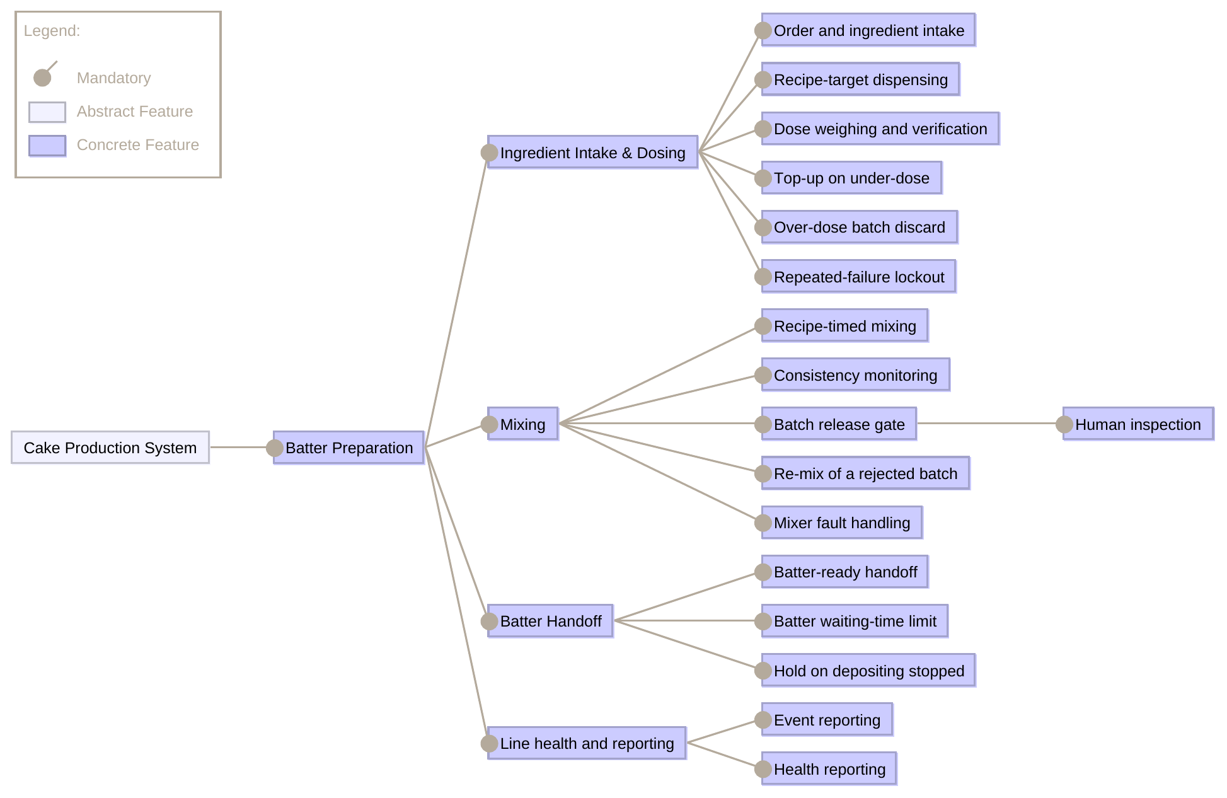

Analysis Blocks

Analysis Functions
ID | Analysis function | Responsibility | Inputs | Outputs | Devices used | Features | Reqs
BAT-AF-01 | Order & Ingredient Intake | Receive the production order and its recipe targets; request the ingredients and accept the reservation result; pass the recipe targets to dosing and the batch ID to Batch Tracking. | Production order and recipe targets; reservation result | Recipe targets to Dosing Control; batch ID to Batch Tracking; ingredient request | none | 02 | 01, 03
BAT-AF-02 | Dosing Control | Dispense each ingredient against its recipe target; act on the verification result by topping up an under-dose or discarding an over-dosed batch; start a new batch after a discard; signal batch loading complete when every ingredient is within tolerance; stop and resume on command from Dosing Fault Lockout. | Recipe targets; dose result; dosing stop / resume | Dispense control; discard control; loading complete; dose failure | Ingredient Dispenser; Batch Discard Chute | 03, 05, 06 | 04.1, 05, 06.1, 07.1, 07.3, 08.2
BAT-AF-03 | Dose Verification | Read the load cell for each dispensed ingredient and judge the measured weight against the recipe target and tolerance. | Weight reading; recipe target and tolerance | Dose result (within tolerance / under / over) | Load Cell Sensor | 04, 05 | 04.2, 04.3, 06.2
BAT-AF-04 | Dosing Fault Lockout | Count consecutive failed dose measurements; stop dosing when the configured limit is reached; publish an error event; release dosing again only once Repair confirmed has been received for the doser. | Dose failure; Repair confirmed | Dosing stop / resume; fault event | none | 07 | 08.1, 08.2, 08.3, 08.4
BAT-AF-05 | Mixing Control | Start the mixing cycle on loading complete, run it for the recipe-defined duration, and signal completion; start a further cycle immediately on a re-mix command; stop on command from Mixer Fault Handling. | Loading complete; consistency status; re-mix command; mix stop | Mix control; mixing complete | Mixer | 09, 14 | 09.1, 09.2, 11.3
BAT-AF-06 | Consistency Monitoring | Monitor batter consistency throughout the mixing cycle and report it to Mixing Control. | Consistency reading | Consistency status | Consistency Sensor | 10 | 10
BAT-AF-07 | Batch Release Gate | Present every finished batch to the human inspector; release a batch for handoff only once it has been marked good; send a re-mix command for every batch not marked good. | Mixing complete; inspection verdict | Batch released; re-mix command | Inspection Terminal | 11, 12 | 11.1, 11.2, 11.3
BAT-AF-08 | Mixer Fault Handling | Detect a mixer fault, stop the mixer, discard the batch that is in it, publish an error event, and release mixing again only once Repair confirmed has been received for the mixer. | Mixer status; Repair confirmed | Mix stop; discard control; fault event | Mixer; Batch Discard Chute | 15 | 13.1, 13.2, 13.3, 13.4
BAT-AF-09 | Batter Handoff Control | Send "Batter ready" for every released batch; track how long finished batter has waited in the mixer and discard it past the configured maximum; hold new batches while depositing is stopped and start a new batch when depositing reports working again. | Batch released; depositing stopped / working again | Batter ready; discard control; waiting-time event | Batch Discard Chute | 17, 18, 19 | 12, 14.1, 14.2, 15.1, 15.2
BAT-AF-10 | Event Reporting | Publish one log, warning, error or discard event (reason, time, batch ID) for every logged, failed or discarded batch in the slice. Central design choice, mirroring the same function in the other slices. | Fault events from Dosing Fault Lockout and Mixer Fault Handling; discard and waiting-time information from Dosing Control and Batter Handoff Control; batch ID from Batch Tracking | Log, warning, error and discard events | none | 21 | 07.2, 08.3, 13.3, 14.3, 16
BAT-AF-11 | Health Reporting | Publish a status for every function and device in the slice at a regular interval. | Status of all functions and devices | Machine status (heartbeat) | none (reads all devices) | 22 | 17
BAT-AF-12 | Batch Tracking | Keep the batch ID with the batch from intake until handoff. Cross-cutting: not a feature of its own. | Batch ID at intake | Batch ID to Event Reporting and Batter Handoff Control | none | cross-cutting (02, 21) | 02

Functional Devices
ID | Device | Kind | Used by | Source | Note
BAT-FD-01 | Ingredient Dispenser | Actuator | Dosing Control | UC3, FC3
BAT-FD-02 | Load Cell Sensor | Sensor | Dose Verification | UC3, FC3, FC4
BAT-FD-03 | Mixer | Actuator | Mixing Control; Mixer Fault Handling | UC4, FC6
BAT-FD-04 | Consistency Sensor | Sensor | Consistency Monitoring | UC4 | UC4 monitors consistency but names no device; added so the function has a source.
BAT-FD-05 | Batch Discard Chute | Actuator | Dosing Control; Mixer Fault Handling; Batter Handoff Control | FC4, FC6, FC7 | One discard path shared by all three discard causes.
BAT-FD-06 | Inspection Terminal | HMI | Batch Release Gate | UC4 | Where the human inspector records the verdict.

Naming and derivation
Which block names come straight from the group report and which were derived from a flow step that names no component. Devices marked Derived are needed to realise a step the report describes; they are recorded here rather than presented as given.
ID | Block | Status | Basis
BAT-AF-02 | Dosing Control | Report calls it Batching Controller | Kept the subsystem-style name used in Table I; the report's actor name is Batching Controller (UC3, FC3, FC4, FC5).
BAT-FD-01 | Ingredient Dispenser | Named in the report | UC3 actor.
BAT-FD-02 | Load Cell Sensor | Named in the report | UC3, FC3, FC4 actor.
BAT-FD-03 | Mixer | Named in the report | UC4, FC6 (Mixer Controller).
BAT-FD-04 | Consistency Sensor | Derived | UC4 has the step “Monitor Consistency” but names no device; one is needed to realise it.
BAT-FD-05 | Batch Discard Chute | Derived | FC4 and FC6 have the step “Discard batch” but name no receptacle.
BAT-FD-06 | Inspection Terminal | Derived | UC4 names the actor Human Inspector; the terminal is where that actor's verdict enters the system.

External Ports
Signal | Direction | Owning analysis function
Production order and recipe targets | In | Order & Ingredient Intake (BAT-AF-01)
Ingredient request and reservation result | In / Out | Order & Ingredient Intake (BAT-AF-01)
Batter ready | Out | Batter Handoff Control (BAT-AF-09)
Depositing stopped / working again | In | Batter Handoff Control (BAT-AF-09)
Log, warning, error and discard events | Out | Event Reporting (BAT-AF-10)
Machine status (heartbeat) | Out | Health Reporting (BAT-AF-11)
Repair confirmed | In | Dosing Fault Lockout (BAT-AF-04); Mixer Fault Handling (BAT-AF-08)

Port List
Every port on a BAT block. A port name appearing on two blocks is one connector in the internal block diagrams.
Block | Port | Direction | Connects to
BAT-AF-01 | Production order and recipe targets | in | system boundary
BAT-AF-01 | Ingredient request and reservation result | inout | system boundary
BAT-AF-01 | Recipe targets | out | BAT-AF-02
BAT-AF-01 | Batch ID | out | BAT-AF-12
BAT-AF-02 | Recipe targets | in | BAT-AF-01
BAT-AF-02 | Dispense control | out | BAT-FD-01
BAT-AF-02 | Dose result | in | BAT-AF-03
BAT-AF-02 | Dose failure | out | BAT-AF-04
BAT-AF-02 | Dosing stop / resume | in | BAT-AF-04
BAT-AF-02 | Loading complete | out | BAT-AF-05
BAT-AF-02 | Discard control | out | BAT-FD-05
BAT-AF-03 | Weight reading | in | BAT-FD-02
BAT-AF-03 | Dose result | out | BAT-AF-02
BAT-AF-04 | Dose failure | in | BAT-AF-02
BAT-AF-04 | Repair confirmed | in | system boundary
BAT-AF-04 | Dosing stop / resume | out | BAT-AF-02
BAT-AF-04 | Fault event | out | BAT-AF-10
BAT-AF-05 | Loading complete | in | BAT-AF-02
BAT-AF-05 | Mix control | out | BAT-FD-03
BAT-AF-05 | Consistency status | in | BAT-AF-06
BAT-AF-05 | Mixing complete | out | BAT-AF-07
BAT-AF-05 | Re-mix command | in | BAT-AF-07
BAT-AF-05 | Mix stop | in | BAT-AF-08
BAT-AF-06 | Consistency reading | in | BAT-FD-04
BAT-AF-06 | Consistency status | out | BAT-AF-05
BAT-AF-07 | Mixing complete | in | BAT-AF-05
BAT-AF-07 | Inspection verdict | in | BAT-FD-06
BAT-AF-07 | Batch released | out | BAT-AF-09
BAT-AF-07 | Re-mix command | out | BAT-AF-05
BAT-AF-08 | Mixer status | in | BAT-FD-03
BAT-AF-08 | Repair confirmed | in | system boundary
BAT-AF-08 | Mix stop | out | BAT-AF-05
BAT-AF-08 | Discard control | out | BAT-FD-05
BAT-AF-08 | Fault event | out | BAT-AF-10
BAT-AF-09 | Batch released | in | BAT-AF-07
BAT-AF-09 | Batter ready | out | system boundary
BAT-AF-09 | Depositing stopped / working again | in | system boundary
BAT-AF-09 | Discard control | out | BAT-FD-05
BAT-AF-09 | Waiting-time event | out | BAT-AF-10
BAT-AF-10 | Fault event | in | BAT-AF-04 / BAT-AF-08
BAT-AF-10 | Waiting-time event | in | BAT-AF-09
BAT-AF-10 | Batch ID | in | BAT-AF-12
BAT-AF-10 | Log, warning, error and discard events | out | system boundary
BAT-AF-11 | Machine status (heartbeat) | out | system boundary
BAT-AF-12 | Batch ID | inout | BAT-AF-01 / BAT-AF-10
BAT-FD-01 | Dispense control | in | BAT-AF-02
BAT-FD-02 | Weight reading | out | BAT-AF-03
BAT-FD-03 | Mix control | in | BAT-AF-05
BAT-FD-03 | Mixer status | out | BAT-AF-08
BAT-FD-04 | Consistency reading | out | BAT-AF-06
BAT-FD-05 | Discard control | in | BAT-AF-02 / BAT-AF-08 / BAT-AF-09
BAT-FD-06 | Inspection verdict | out | BAT-AF-07

Traceability
Every use case and failure case owned is the source of at least one requirement, and every requirement reaches a feature and at least one block.
Source (UC/FC) | Req ID | Rationale | Feature ID | Block ID(s)
UC3 | BAT-REQ-01 | Entry point of the slice; dosing cannot start without recipe targets. | BAT-FEAT-02 | BAT-AF-01
UC3, UC4 | BAT-REQ-02 | Batch traceability for recall; the batch ID is reported with every discard event. | BAT-FEAT-21 | BAT-AF-12
UC3, FC1, FC2 | BAT-REQ-03 | Ingredients must be reserved before dosing starts; insufficient stock stops the batch before any ingredient is dispensed. | BAT-FEAT-02 | BAT-AF-01
UC3 | BAT-REQ-04.1 | Normal dosing flow. | BAT-FEAT-03 | BAT-AF-02, BAT-FD-01
UC3 | BAT-REQ-04.2 | A dispensed quantity that is never measured cannot be checked against the recipe. | BAT-FEAT-04 | BAT-AF-03, BAT-FD-02
UC3 | BAT-REQ-04.3 | Comparison against the target is what turns a measurement into a pass or a fail. | BAT-FEAT-04 | BAT-AF-03
UC3 | BAT-REQ-05 | Only correctly weighed ingredients may be loaded into the mixer (UC3 postcondition). | BAT-FEAT-04 | BAT-AF-02
FC3 | BAT-REQ-06.1 | An under-dose is recoverable, so the batch is topped up rather than wasted. | BAT-FEAT-05 | BAT-AF-02, BAT-FD-01
FC3 | BAT-REQ-06.2 | A top-up is only a correction if the result is verified; otherwise the batch may still be wrong. | BAT-FEAT-05 | BAT-AF-03, BAT-FD-02
FC4 | BAT-REQ-07.1 | An over-dose cannot be corrected by removing ingredient, so the batch is lost. | BAT-FEAT-06 | BAT-AF-02, BAT-FD-05
FC4 | BAT-REQ-07.2 | A discarded batch must stay traceable for recall and for the waste figures. | BAT-FEAT-06 | BAT-AF-10
FC4 | BAT-REQ-07.3 | Production continues after a discard; the order is still outstanding. | BAT-FEAT-06 | BAT-AF-02
FC5 | BAT-REQ-08.1 | Repeated failures point at a faulty doser rather than at a bad batch. | BAT-FEAT-07 | BAT-AF-04
FC5 | BAT-REQ-08.2 | Stopping bounds the waste: without a limit a faulty doser keeps spoiling batches. | BAT-FEAT-07 | BAT-AF-04, BAT-AF-02
FC5 | BAT-REQ-08.3 | Maintenance is notified through Line Monitoring & Health. | BAT-FEAT-07 | BAT-AF-04, BAT-AF-10
FC5 | BAT-REQ-08.4 | Prevents restarting on a doser that is still faulty. | BAT-FEAT-07 | BAT-AF-04
UC4 | BAT-REQ-09.1 | Normal mixing flow. | BAT-FEAT-09 | BAT-AF-05, BAT-FD-03
UC4 | BAT-REQ-09.2 | Under-mixing and over-mixing both spoil the batter, so the duration is recipe-defined rather than fixed. | BAT-FEAT-09 | BAT-AF-05
UC4 | BAT-REQ-10 | Consistency is monitored during mixing (UC4 normal flow). | BAT-FEAT-10 | BAT-AF-06, BAT-FD-04
UC4 | BAT-REQ-11.1 | Business rule: every mixed batter batch must be human-inspected before being allowed for further production. | BAT-FEAT-12 | BAT-AF-07, BAT-FD-06
UC4 | BAT-REQ-11.2 | The business rule makes the inspection a gate, not an advisory step. | BAT-FEAT-11 | BAT-AF-07
UC4 | BAT-REQ-11.3 | A rejected batch is re-mixed rather than discarded (UC4 alternative flow). | BAT-FEAT-14 | BAT-AF-07, BAT-AF-05
UC4 | BAT-REQ-12 | Handoff point of the slice. | BAT-FEAT-17 | BAT-AF-09
FC6 | BAT-REQ-13.1 | Mixer fault handling. | BAT-FEAT-15 | BAT-AF-08, BAT-FD-03
FC6 | BAT-REQ-13.2 | Batter left in a stopped mixer cannot be used. | BAT-FEAT-15 | BAT-AF-08, BAT-FD-05
FC6 | BAT-REQ-13.3 | Maintenance can only be dispatched for a fault that has been reported. | BAT-FEAT-15 | BAT-AF-08, BAT-AF-10
FC6 | BAT-REQ-13.4 | Restarting on an unrepaired mixer would simply spoil the next batch. | BAT-FEAT-15 | BAT-AF-08
FC7 | BAT-REQ-14.1 | Batter has a shelf life once mixed. | BAT-FEAT-18 | BAT-AF-09
FC7 | BAT-REQ-14.2 | Batter past its waiting limit would produce an out-of-spec cake further down the line. | BAT-FEAT-18 | BAT-AF-09, BAT-FD-05
FC7 | BAT-REQ-14.3 | Waiting-time discards are the measure of how costly a depositing stop was. | BAT-FEAT-18 | BAT-AF-10
FC7 | BAT-REQ-15.1 | Availability: producing batter that cannot be deposited only creates more waste. | BAT-FEAT-19 | BAT-AF-09
FC7 | BAT-REQ-15.2 | Production resumes without manual intervention once the cause has cleared. | BAT-FEAT-19 | BAT-AF-09
UC2, FC4, FC5, FC6, FC7 | BAT-REQ-16 | Central reporting; feeds traceability and the group failure table. | BAT-FEAT-21 | BAT-AF-10
UC2, FC5, FC6 | BAT-REQ-17 | Lets the Health Monitor detect a station that has stopped responding (FC28). | BAT-FEAT-22 | BAT-AF-11
quality attribute | BAT-NFR-01 | Availability is the group's driving quality attribute. A fault in batter preparation must not reach back into product that has already left the slice. | BAT-FEAT-00 | BAT-AF-04, BAT-AF-08
quality attribute | BAT-NFR-02 | The organising principle of the slice: keep the blast radius of a fault at one batch, so a fault is an inconvenience rather than an outage. | BAT-FEAT-06 | BAT-AF-02, BAT-AF-08
quality attribute | BAT-NFR-03 | An unresponsive warehouse system should slow the slice down, not stop it. Work already paid for should still be completed. | BAT-FEAT-02 | BAT-AF-01
quality attribute | BAT-NFR-04 | Containment and recovery both depend on the fault being noticed. An unbounded detection window makes every other availability claim unverifiable. | BAT-FEAT-22 | BAT-AF-11
quality attribute | BAT-NFR-05 | A slice that needs hand-holding to restart turns a short fault into a long one. Recovery should follow the repair automatically. | BAT-FEAT-07 | BAT-AF-04, BAT-AF-08
quality attribute | BAT-NFR-06 | Continuous deployability is a stated system requirement, and the report already records both subsystems as independently deployable. It is also what lets an availability fix be shipped without a production stop. | BAT-FEAT-01 | BAT-AF-02, BAT-AF-05

Block Definition Diagrams

Dosing
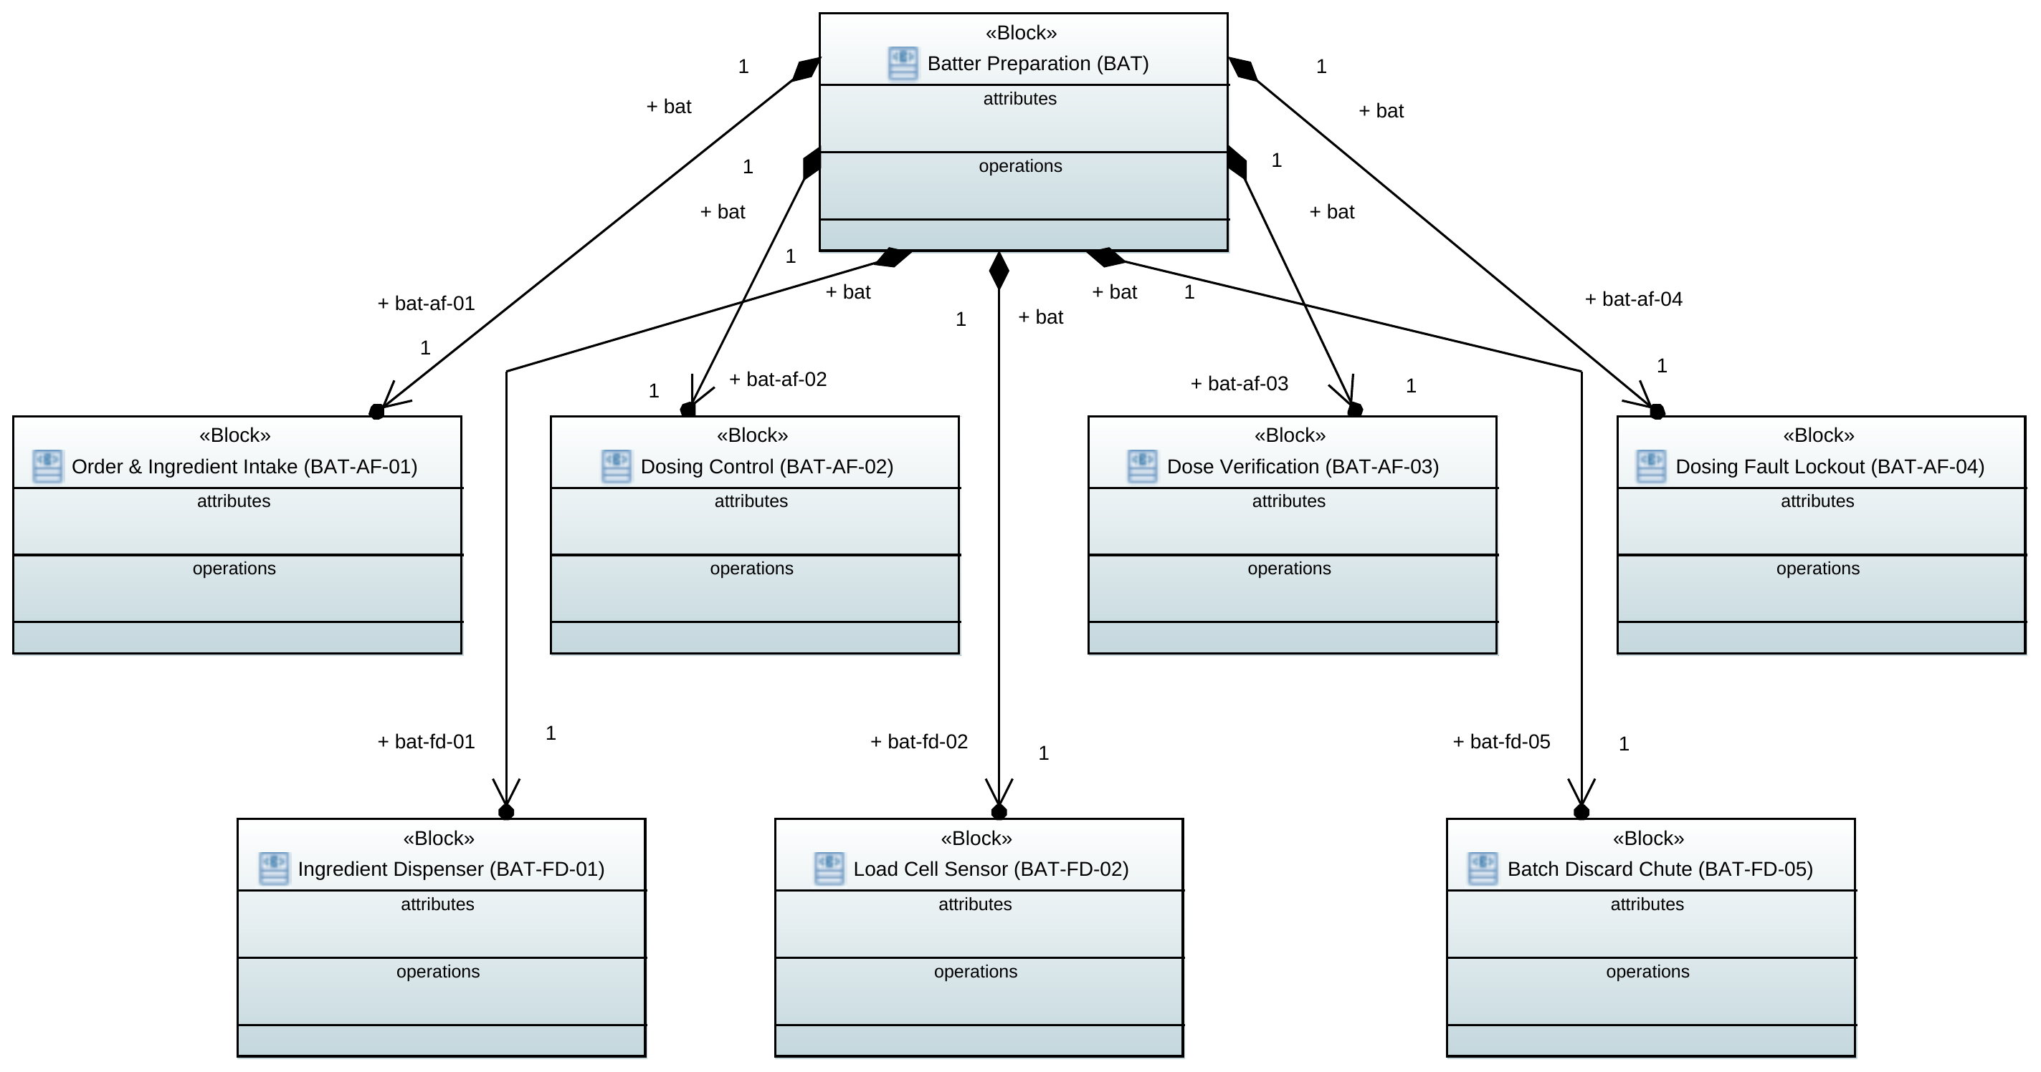

Mixing
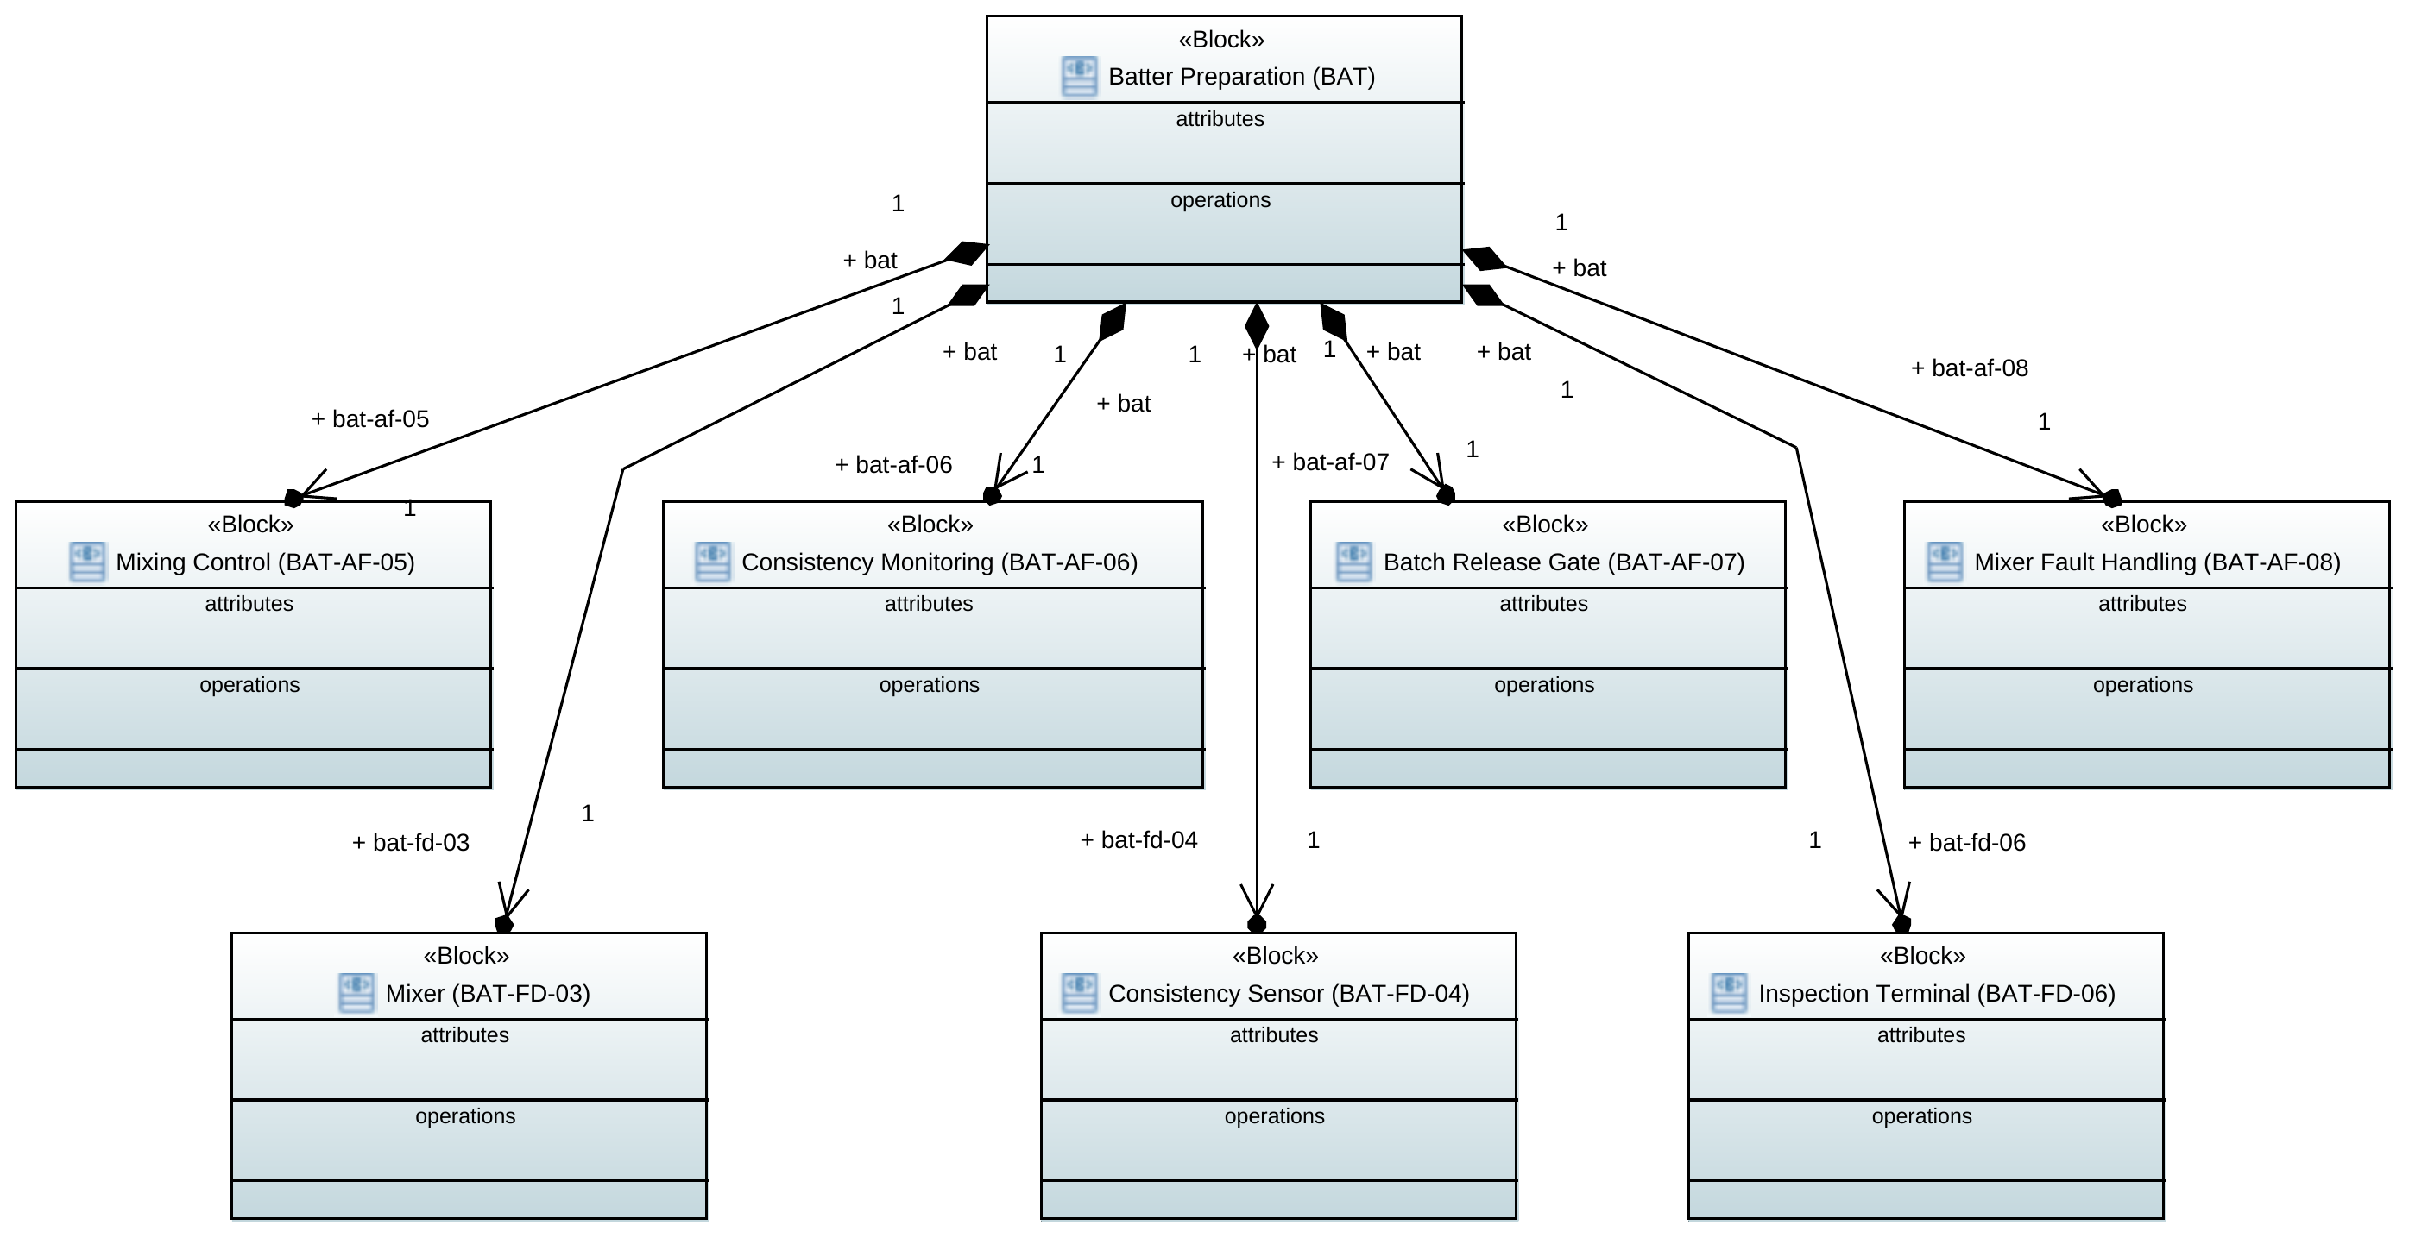

Handoff
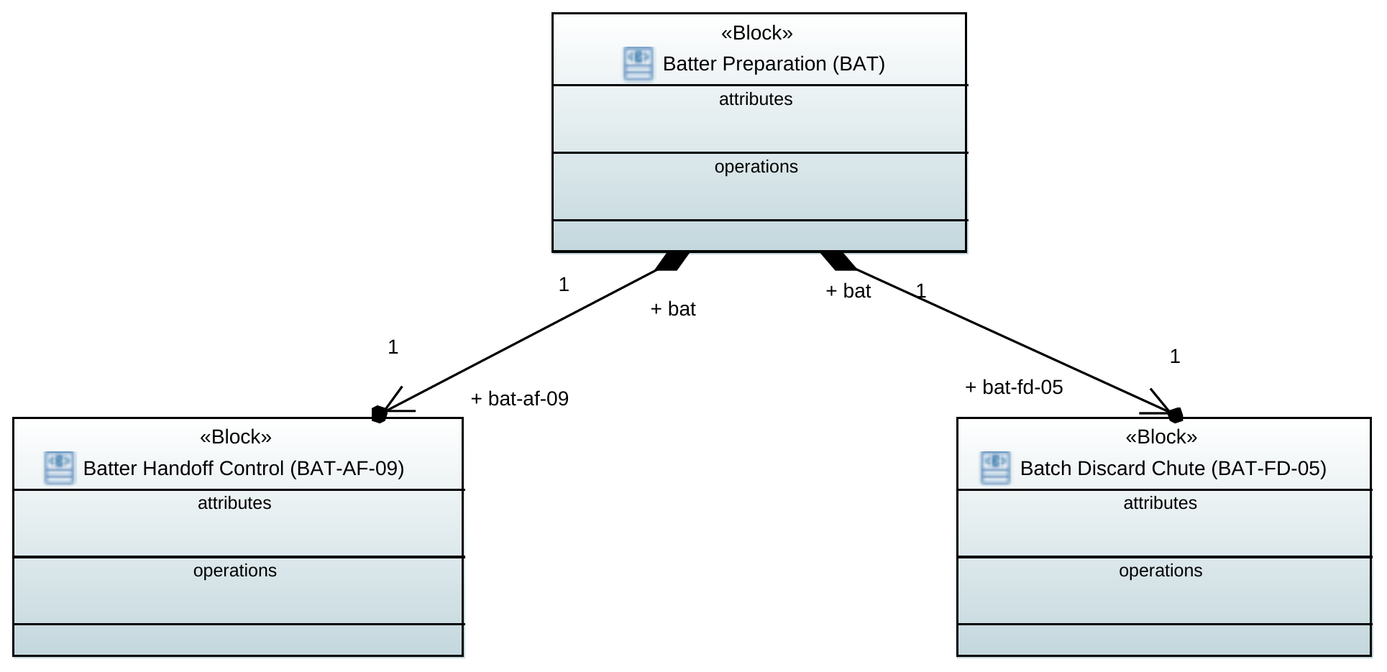

Reporting
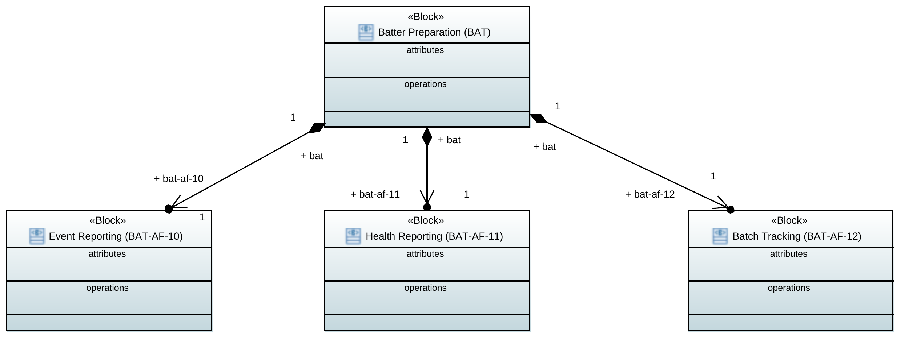

Internal Block Diagrams

Dosing
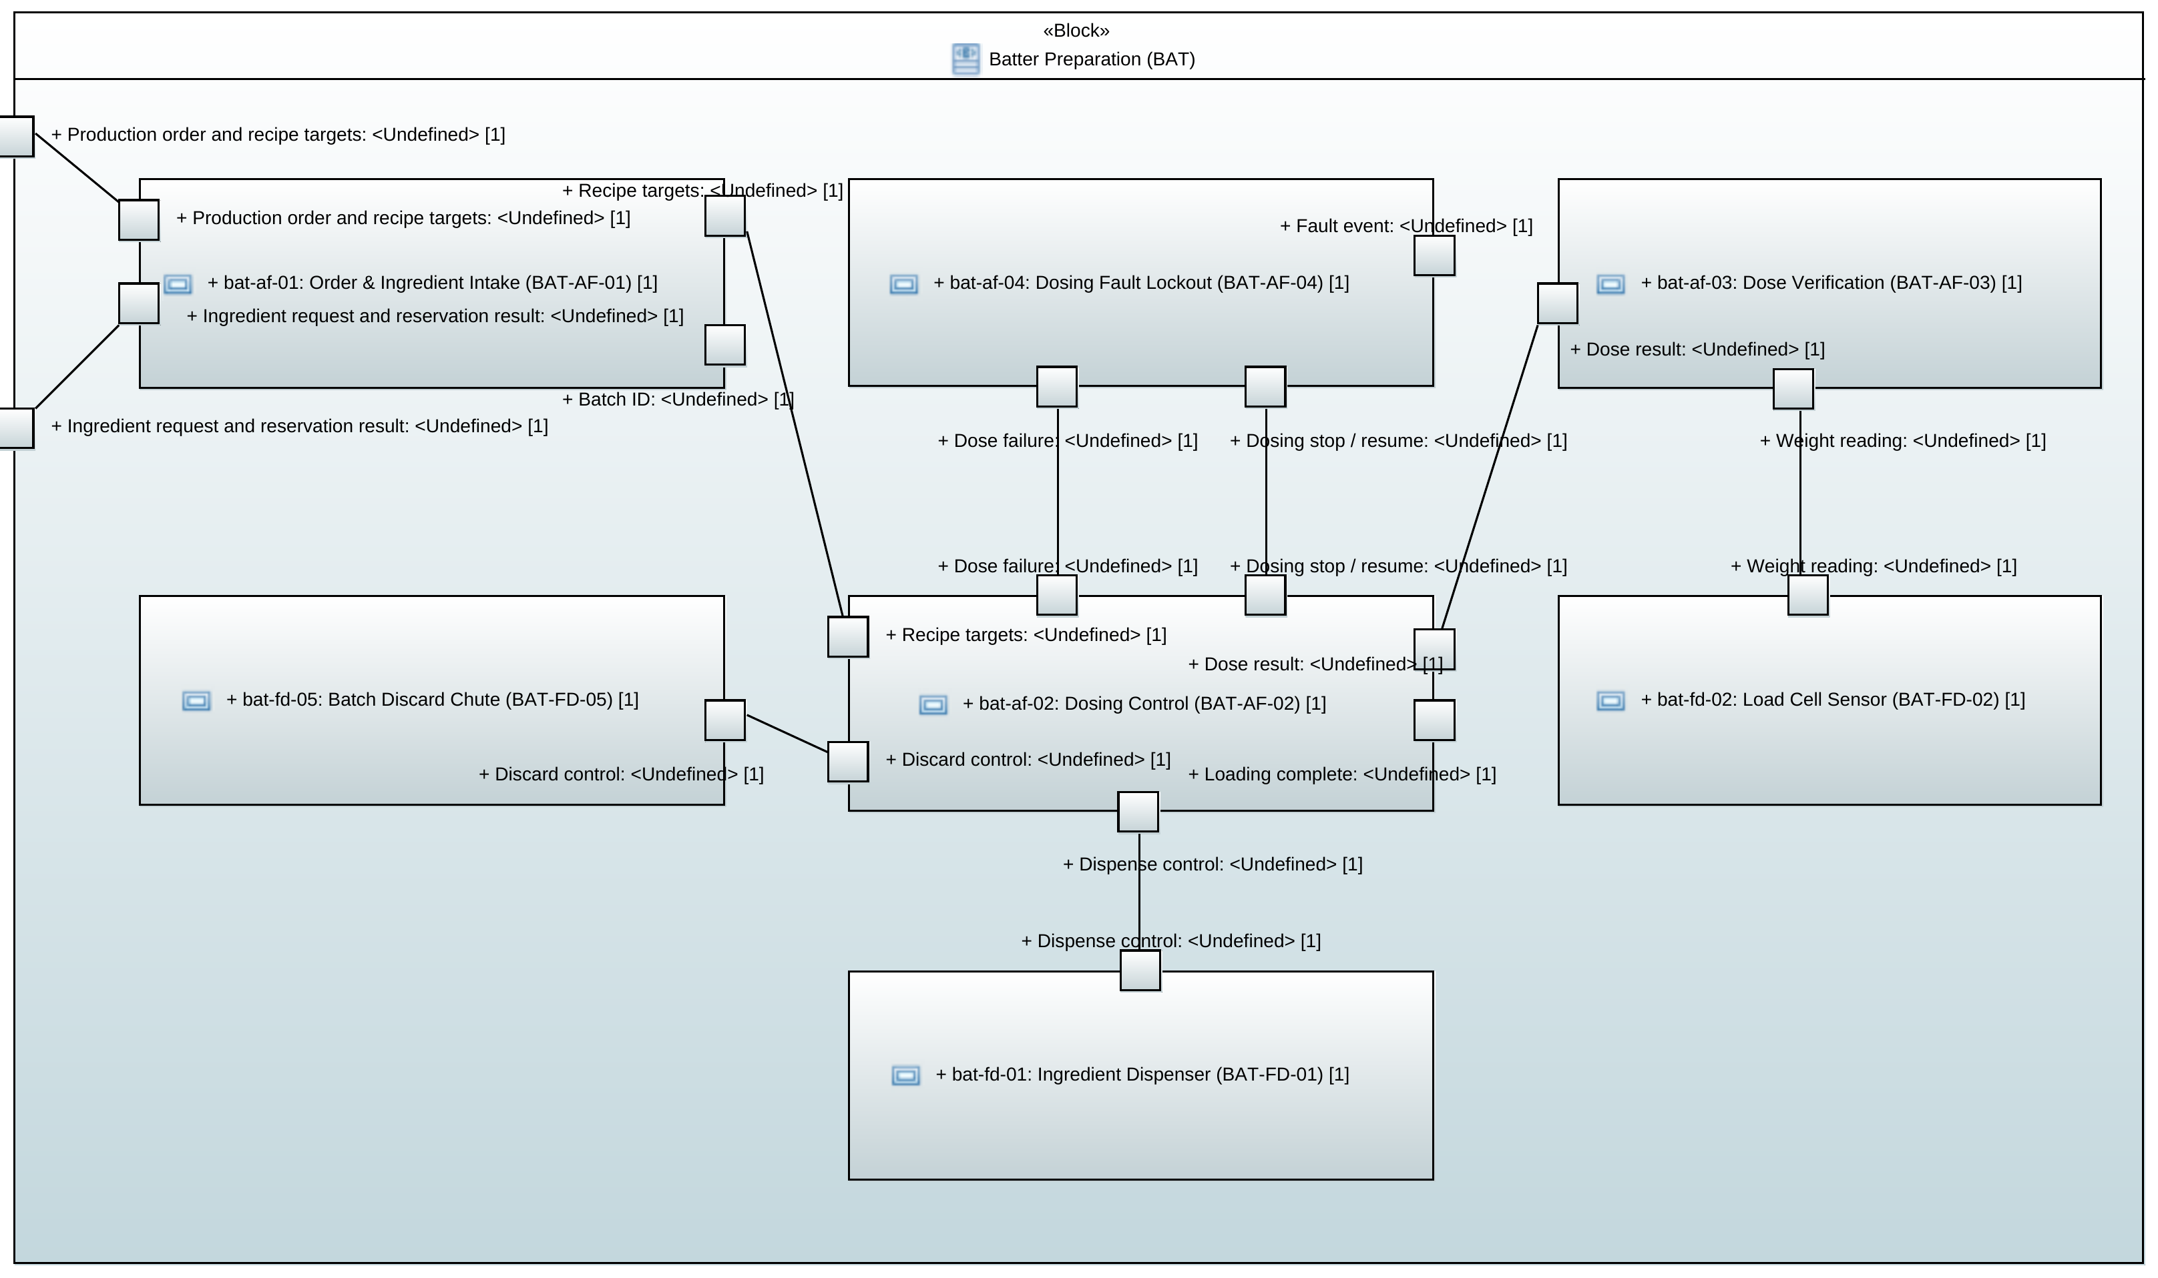

Mixing
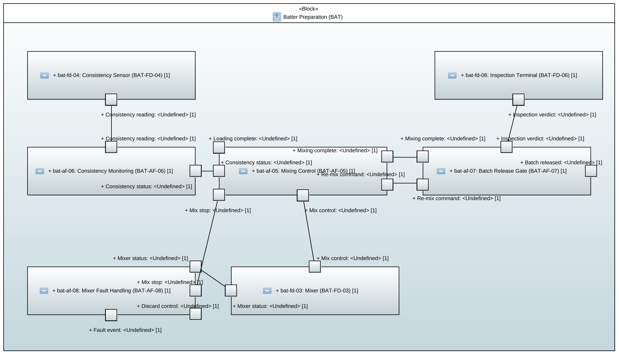

Handoff
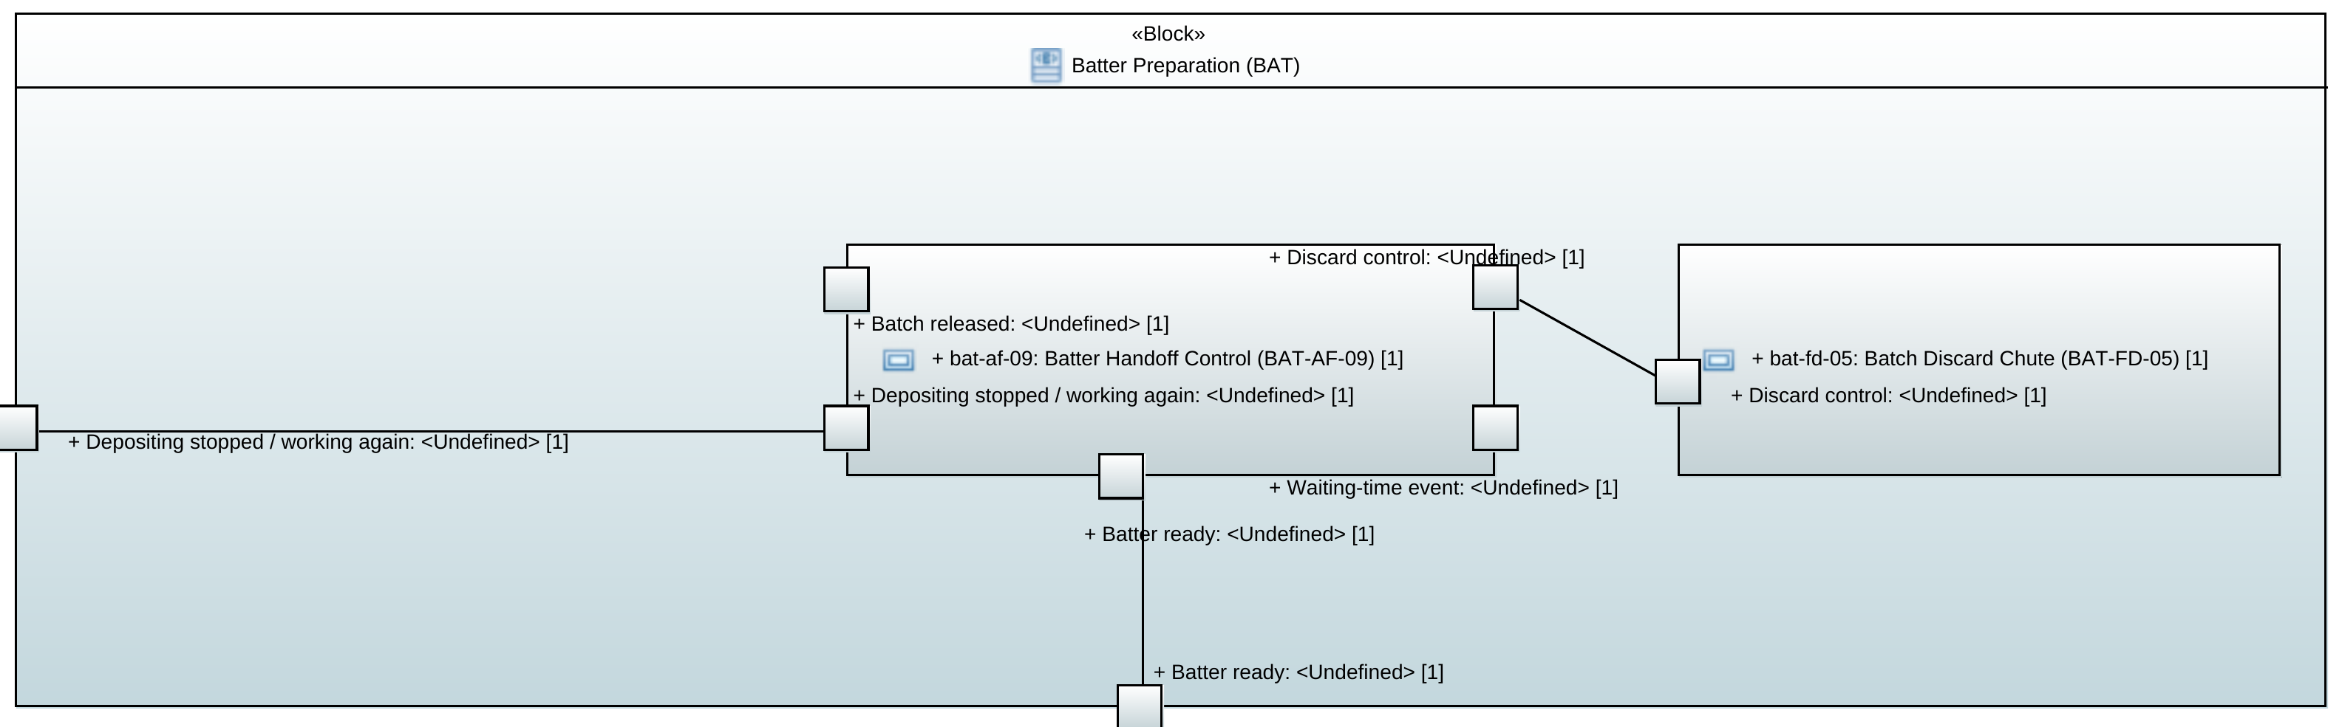

Reporting
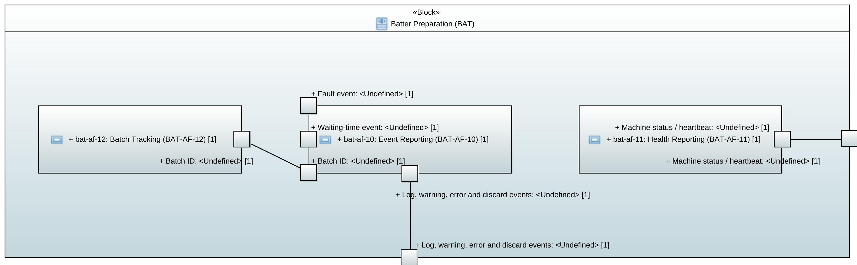

SysML Discussion (lecture 4, slide p. 30)

Q1. In a Model-Driven Engineering approach, which key aspects of SysML will do the heavy lifting to transform the design into executable code or physical system constraints, and why?
Four parts of SysML do the real work here. The rest is there to describe what you mean, not to generate anything from it.
- Blocks with typed ports and item flows: This is what makes code generation possible at all. Once the port "Batter ready" has a type on it, a batch ID and a quantity, it maps straight onto a message definition and a publisher on the bus, which is what the course wants from point-to-point communication between languages (protocol buffers). An untyped box gives you nothing. It is also how the five of us merge our slices: we each model one end of an interface, and the ports connect because the names and payloads match.
- State machines. Our availability story is about state, not structure. Dosing locks out after repeated failures, the mixer fault handler stops and discards the batch, handoff holds batches while depositing is stopped. State machines are precise enough to turn into both running code and a model a checker can run.
- Constraint blocks and parametrics. This is where the physical limits live: the 97 °C ± 0.5 core temperature, the dose tolerance per ingredient, how long mixed batter may wait. Bound to block properties they can be checked, while written in a requirements table they can only be read.
- Allocation and the requirement links (satisfy, verify, derive, trace). These make our traceability machine-readable instead of a table we keep by hand, so changing a requirement shows us which blocks it affects.

One caveat: SysML is uneven at this. Structure generates reliably. Behaviour only generates well if we commit to a single action language, otherwise we get stubs someone still has to fill in. Parametrics mostly don't generate code at all; they feed analysis tools instead.

Q2. With budget to fully develop only three SysML diagram types, which three do you prioritise to capture the most critical behaviours or risks, and what are you willing to leave out?
We picked these three by thinking about where the project can actually go wrong: merging five slices that were modelled separately, fault and recovery behaviour (Availability is our driving quality attribute), and the physical limits that decide whether the product is good.
- Block Definition Diagram (which is like the vocabulary): It fixes the analysis functions, the devices, how they compose into the system block, and the types the ports will carry. Nothing else can be drawn before this exists, and it is what stops five people calling the same thing by three different names.
- Internal Block Diagram: This is where the merge either works or doesn't. We each model our own end of an interface as a named port, and if two ports don't match, the IBD shows it now rather than during implementation. It also carries the decisions like: what sits in which container, what goes over the message bus, where the point-to-point links are.
- State Machine Diagram: Everything interesting here happens over time: detect a fault, isolate it, hold the product, call maintenance, bring the repaired machine back, resume. A BDD and an IBD have no time in them. A state machine does, and it feeds the verification work later in the course.
What we give up: Use case and activity diagrams are the easiest to drop, because the report already has sixteen use case tables and twenty-eight failure cases with their flows, so redrawing them in SysML would add notation to content we already have. What we lose is the formal link between those flows and the blocks behind them, and the traceability table covers that instead. Sequence diagrams go the same way, though we would miss them for the cross-slice handshakes like batter handoff to depositing; we specify those as named signals in the interface table.
Parametric and requirement diagrams are the ones that cost us. Without parametrics the dose tolerance, the 97 °C target and the waiting limit stay as text on requirements instead of being bound to block properties, so we encode them in the formal models we verify. Without requirement diagrams we cover the course’s requirement representation through traceability tables rather than satisfy and verify links. At this size a table works and is easy to audit. On a real product line it wouldn't.

